**PROJECT REPORT**

**A PERSONALIZED TRAVEL PLANNING AND TRACKING APP**

**1.INTRODUCTION**

**1.1 OVERVIEW**

A project built using the Android Compose UI toolkit. It demonstrates how to create a simple Travel app using the Compose libraries. It also features a personalized feed of recommended Accommodations based on the locations. A mobile travel app is a software application that has been developed specifically for use on smaller devices, such as smartphones and tablets, and can be used by business travellers to book and manage their travel whilst on the move. Booking travel, altering bookings, and reviewing itineraries are key features available in most mobile travel applications.

A travel app helps them to organize their trip smoothly, swiftly, and cost-effectively. From finding a hotel to booking airline tickets, travel apps now include all sophisticated features to provide customers with fast and accurate services at their finger’s touch.

**1.2 PURPOSE**

These days market is all about reaching out to the customers with much ease of access and nothing works like Apps. Market is all about providing convenience to the customers. So all big OTA players are launching the same services like hotel flights and other bookings to be executed through Apps. Which would help them to have focused customer base and very specific search queries coming in from their apps.

So purpose of this online travel apps to help customers to make the same type of bookings but without going to any websites and at the same time Online Travel Agencies also focuses by doing specific promotions through these Apps to louver more customers on their apps

**2.PROBLEM DEFINITION& DESIGN THINKING**

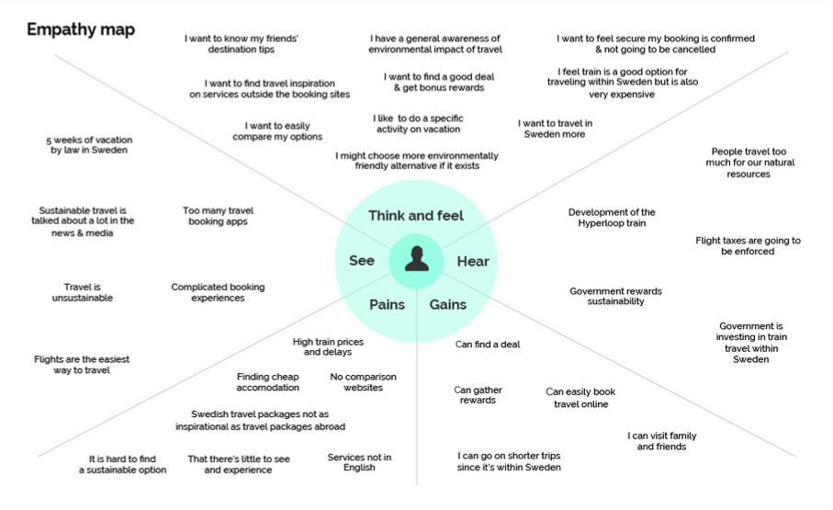**2.1 EMPATHY MAP**

**2.2 IDEATION& BRAINSTORMING MAP**

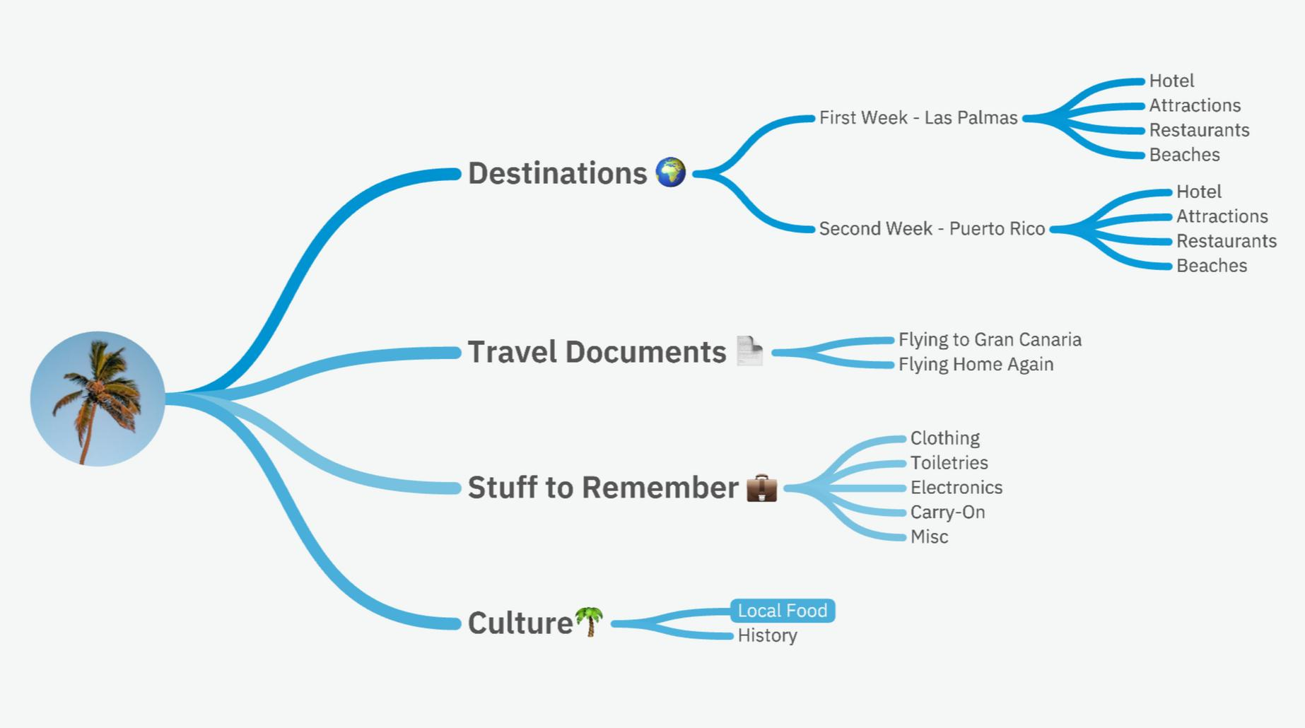

**3. RESULT**

**3.1 DATA MODEL**

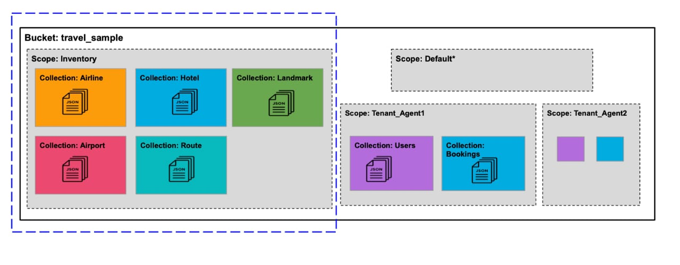

**3.2 ACTIVITY & SCREENSHOT**

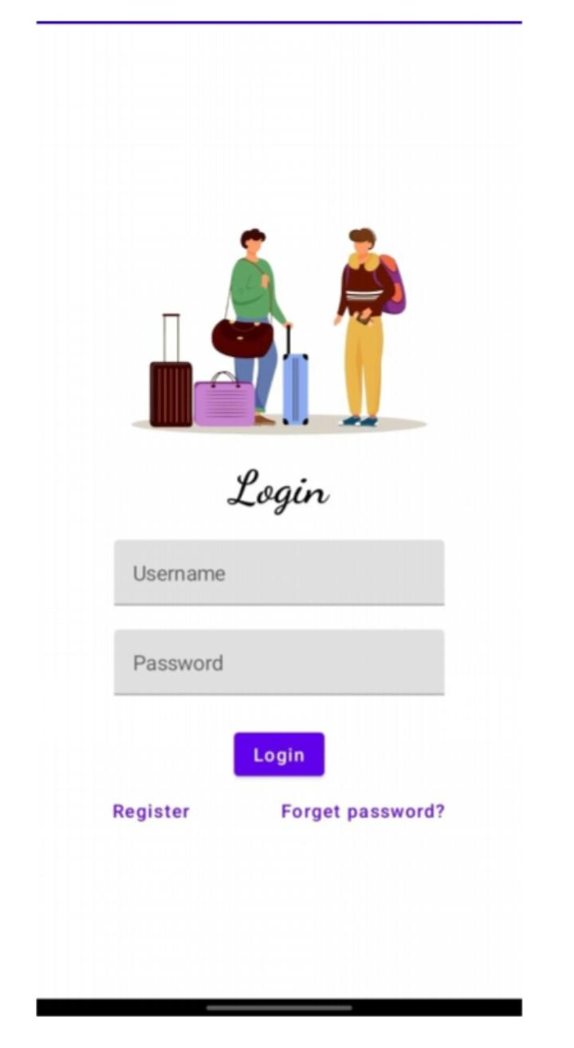**LOGIN PAGE**

**REGISTER PAGE**

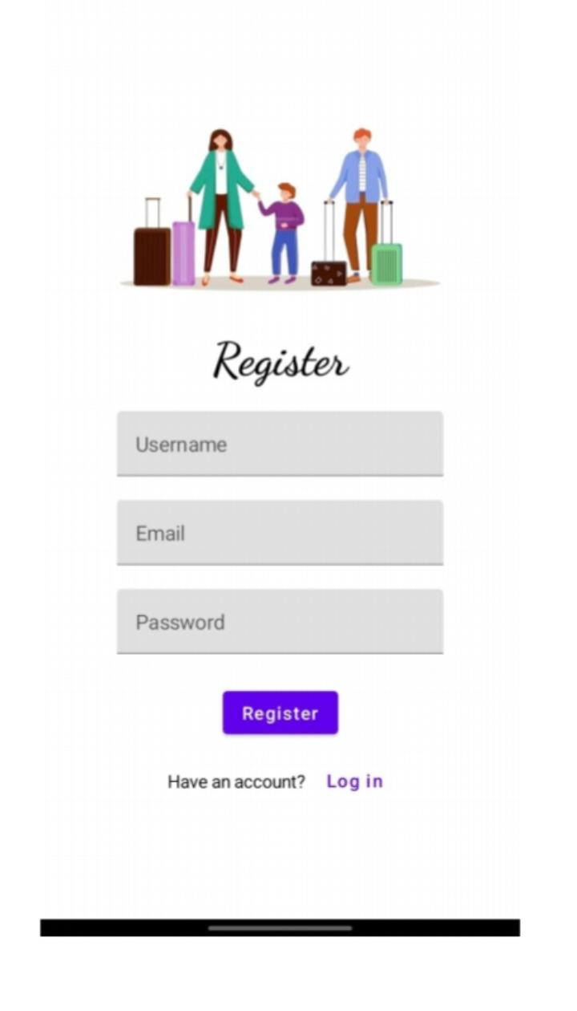

**MAIN PAGE**

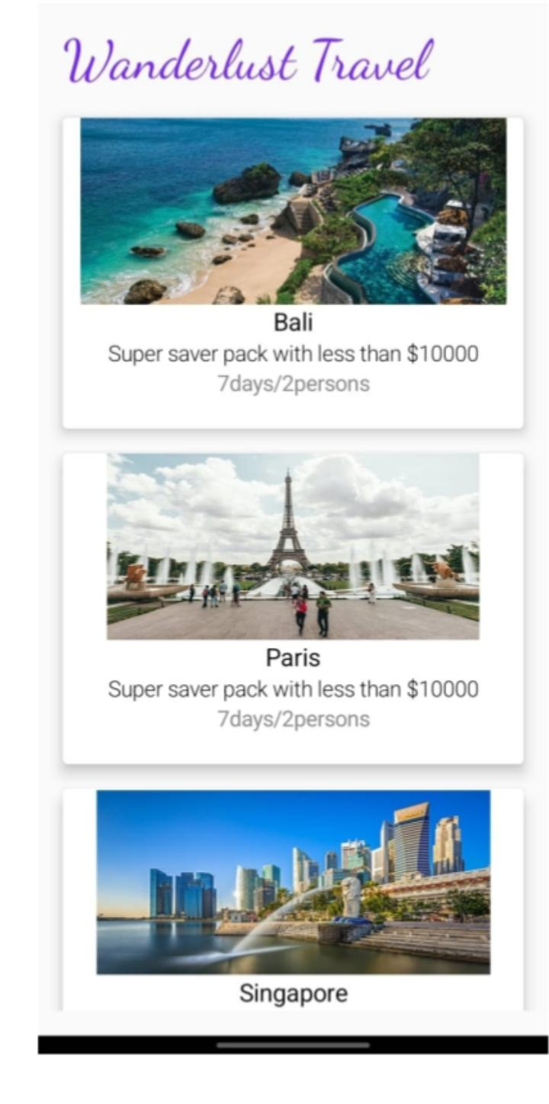

**LOCATION PAGE**

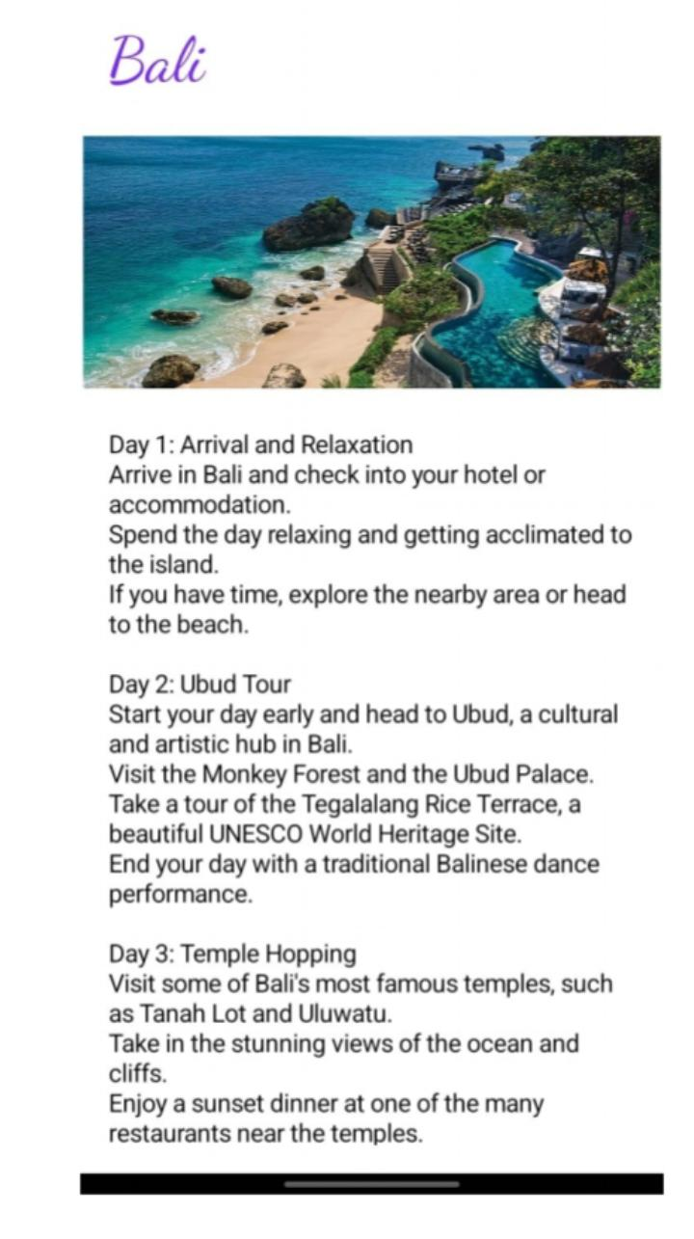

**4. TRAILHEAD PROFILE PUBLIC URL**

Team Lead - DEEPA.P - <https://trailblazer.me/id/diiibsc-cs>

Team Member 1 - DIVYA.D - <https://trailblazer.me/id/ddivya90>

Team Member 2 - ANGAPPAN.A - <https://trailblazer.me/tbrecovery>

Team Member 3 - ARUN.A - <https://trailblazer.me/id/avengance>

**5. ADVANTAGES & DISADVANTAGE**

**5.1 ADVANTAGES OF TRACKING APP**

* Experience New Cultures.
* Personal Growth.
* Lower Cost Of Living.
* Make New Friends.
* It Can Be Expensive.
* Sickness.
* It Can Be Lonely.
* Travel application is one place to get every service regarding traveling.
* One-step Ahead.
* Constant Reminder.
* Easy to Spread Information.
* Digital Customer, Digital Services.
* Easy Transaction

**5.2 DISADVANTAGES OF TRACKING APP**

* Not Everyone Can Use Them.
* Hard to Create.
* Have to Pay to Make the App Available.
* Security.
* Frequent Updates Are Required.
* Support.
* Need Both a Website and an App.

**6. APPLICATIONS**

Software has changed how people travel, where they travel, when they travel, and even how they share their travels with others. It has also allowed for the democratization of travel, enabling travellers to easily book flights, hotels, and adventure tours.

With the addition of new technology, travel has become more comfortable, providing travellers with the opportunity to access the Internet in-flight, book travel accommodations in advance, and see reviews of restaurants and tourist attractions.

This is where custom software can help! With custom travel apps and software, businesses and entrepreneurs alike can quickly take on the unique challenges of their customers and provide flight comparison services, travel insurance, and hotel booking services to create a seamless travel management platform and quickly fill gaps in the market.

**7. CONCLUSION**

In conclusion, we can say that tourism is a very productive activity both for the tourist and the government. As they support each other simultaneously. Also, the government should consider improving the conditions of the country as more and more number of tourist visit their country.

**8.FUTURE SCOPE**

The industry is one of the largest and most profitable industries in India and contributes significantly to the foreign exchange earned. As per various studies, the industry is expected to create over 45 million jobs in India by 2025Technology is continuously evolving and will continue to do so in the coming era. The change in the technology is also impacting the industries like cosmetic industry, health industry, education, entertainment, the travel industry and many more.

Travel and tourism industry is no longer hidden and gone are the days when travelling the world was like an unknown step. It has transformed and technology has reinvented the different ways to explore travelling for you so that you will find places easily.

Now travel agencies and physical booking are diminishing due to the travel mobile apps. According to the survey travel-based mobile apps are on the 5th position in the downloaded category and 60% of smartphone users prefer to use travel and tourism apps while planning their holidays rather than going to travel agents.

**9. APPENDICES**

1. **SOURCE CODE**

<?xml version="1.0" encoding="utf-8"?>

<manifest xmlns:android="http://schemas.android.com/apk/res/android"

xmlns:tools="http://schemas.android.com/tools">

<application

android:allowBackup="true"

android:dataExtractionRules="@xml/data_extraction_rules"

android:fullBackupContent="@xml/backup_rules"

android:icon="@mipmap/ic_launcher"

android:label="@string/app_name"

android:supportsRtl="true"

android:theme="@style/Theme.TravelApp"

tools:targetApi="31">

<activity

android:name=".RegisterActivity"

android:exported="false"

android:label="RegisterActivity"

android:theme="@style/Theme.TravelApp" />

<activity

android:name=".SingaporeActivity"

android:exported="false"

android:label="@string/title_activity_singapore"

android:theme="@style/Theme.TravelApp" />

<activity

android:name=".ParisActivity"

android:exported="false"

android:label="@string/title_activity_paris"

android:theme="@style/Theme.TravelApp" />

<activity

android:name=".BaliActivity"

android:exported="false"

android:label="@string/title_activity_bali"

android:theme="@style/Theme.TravelApp" />

<activity

android:name=".MainActivity"

android:exported="true"

android:label="@string/app_name"

android:theme="@style/Theme.TravelApp"/>

<activity

android:name=".LoginActivity"

android:exported="true"

android:label="@string/app_name"

android:theme="@style/Theme.TravelApp">

<intent-filter>

<action android:name="android.intent.action.MAIN" />

<category android:name="android.intent.category.LAUNCHER" />

</intent-filter>

</activity>

</application>

</manifest>